Practical 3 :

Code :

import java.util.*;

class great_small{

    public static void main(String[] args) {

        Scanner sc=new Scanner(System.in);

        System.out.print("Enter First No : ");

        int a = sc.nextInt();

        System.out.print("Enter Second No : ");

        int b = sc.nextInt();

        if(a<b)

        System.out.print(a+" is Smaller Than "+b);

        else if(a<b)

        System.out.print(a+" = "+b);

        else

        System.out.print(a+" is Greater Than "+b);

        sc.close();

    }}

Output :

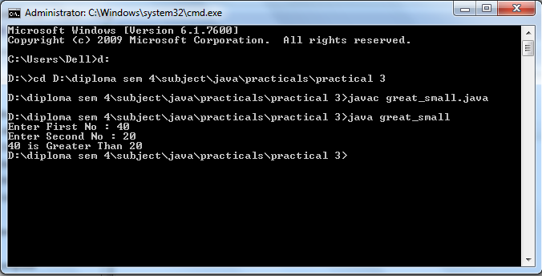

Code :

class Logic {

    public static void main(String[] args) {

        System.out.println((5<3)||(4<5));

        System.out.println((5<3)||(4>5));

    }

}

Output :

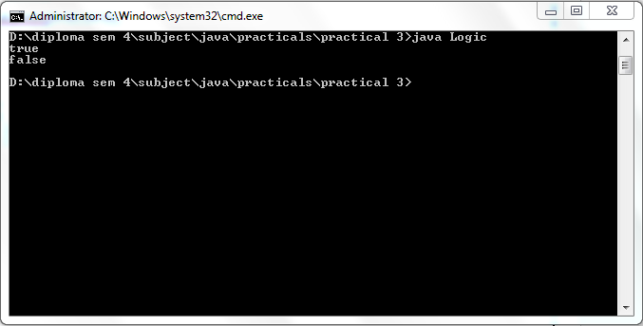

Code :

import java.util.*;

class Eodd{

    public static void main(String[] args) {

        Scanner sc = new Scanner(System.in);

        System.out.print("Enter any number : ");

        int a =sc.nextInt();

        if (a%2==0)

        System.out.println(a+" Is Enven");

        else

        System.out.print(a+" Is Odd");

    }

}

Output :

